Procedure I ‐ Part A ‐ Baby bugs produced when the parents are BB and bb
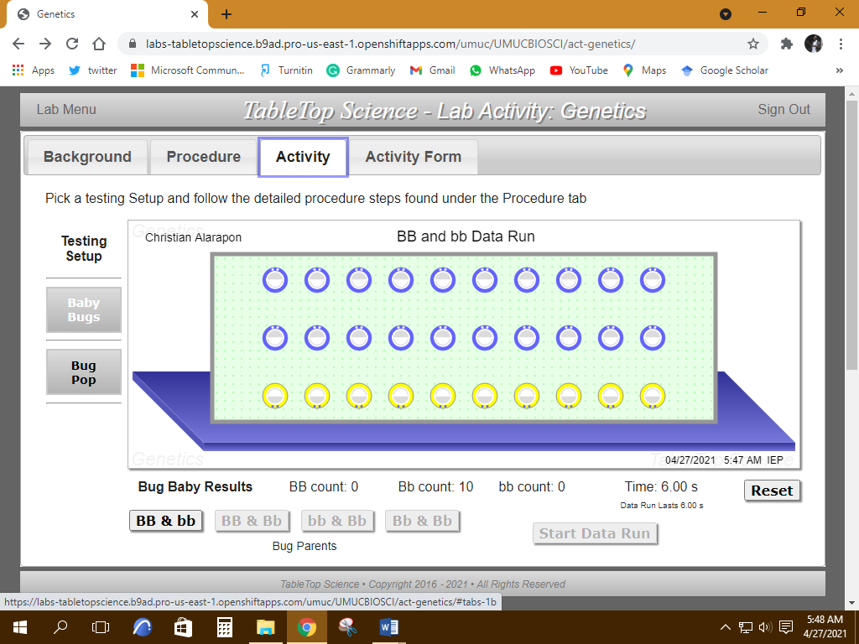

Procedure I ‐ Part B ‐ Baby bugs produced when the parents are BB and Bb

Procedure I ‐ Part B, 1
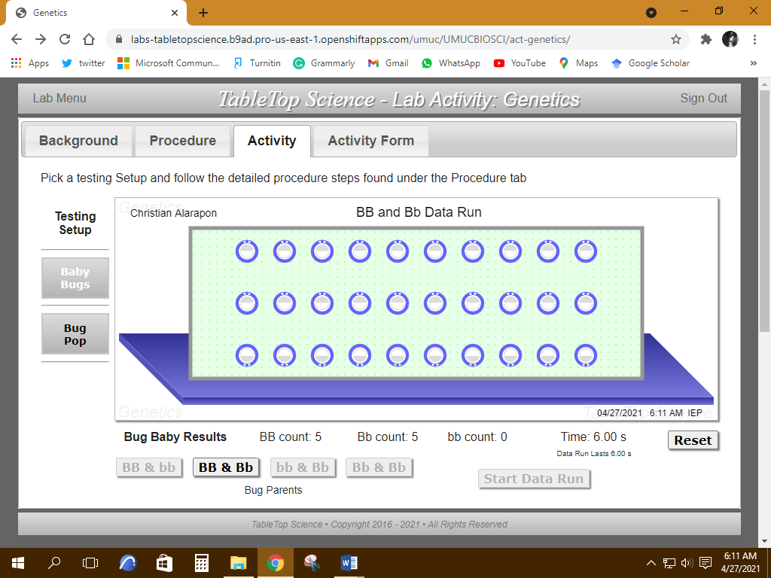

Procedure I ‐ Part B, 2
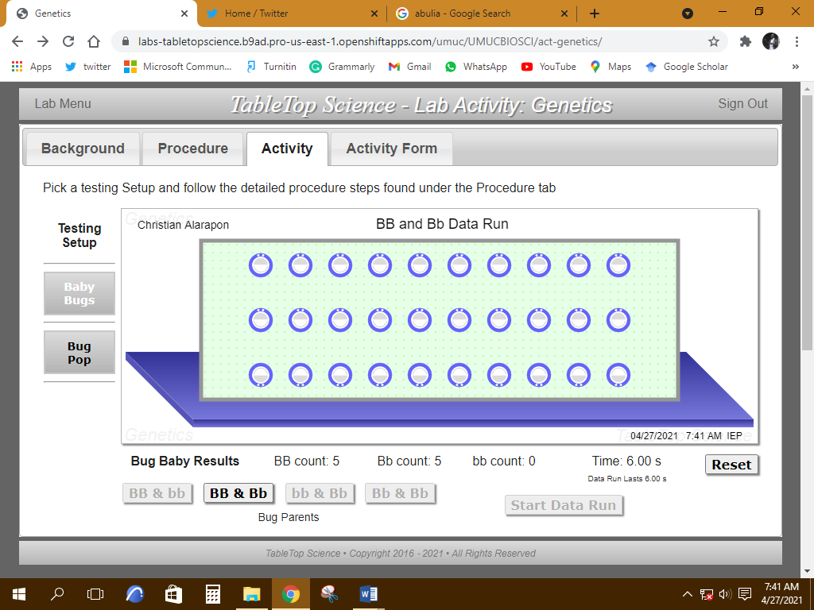
Procedure I ‐ Part B 3
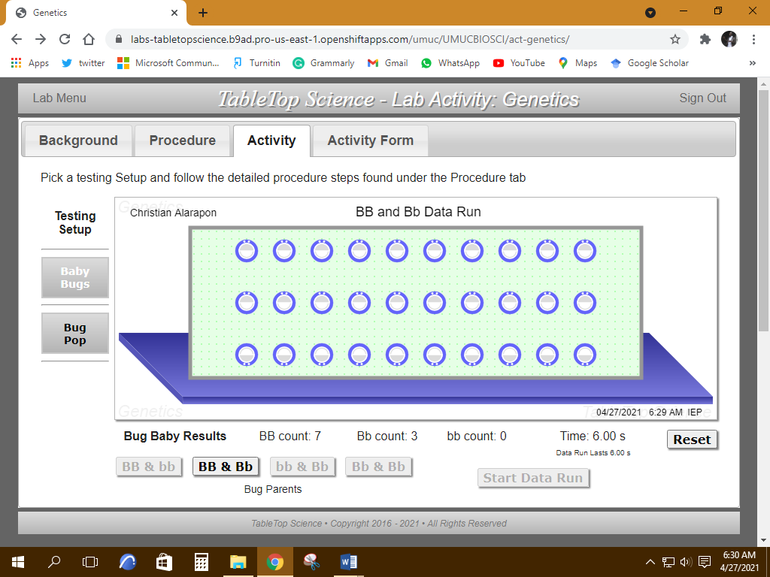
Procedure I ‐ Part B 4
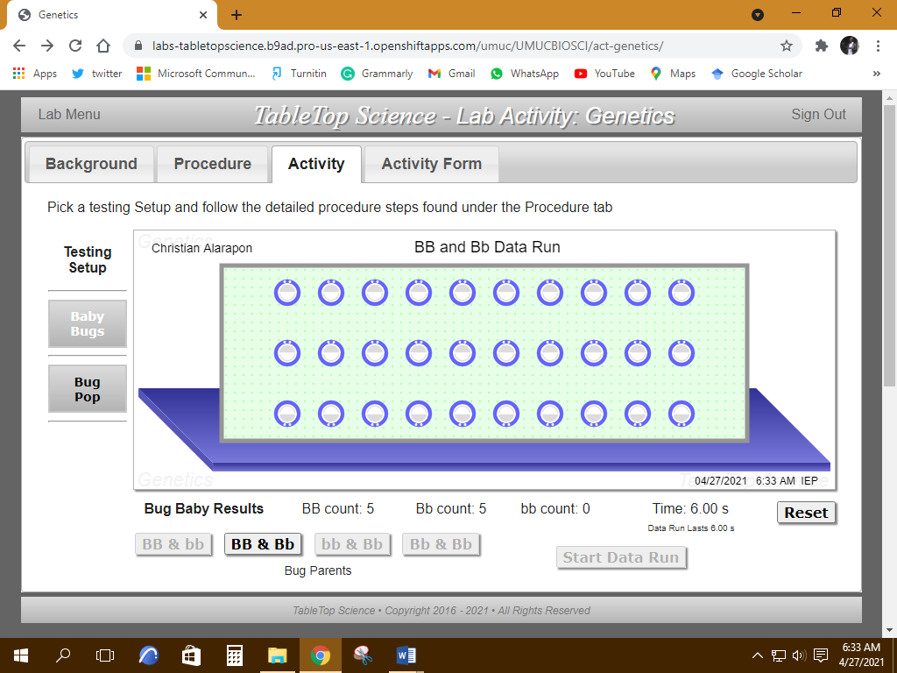
Procedure I ‐ Part B 5
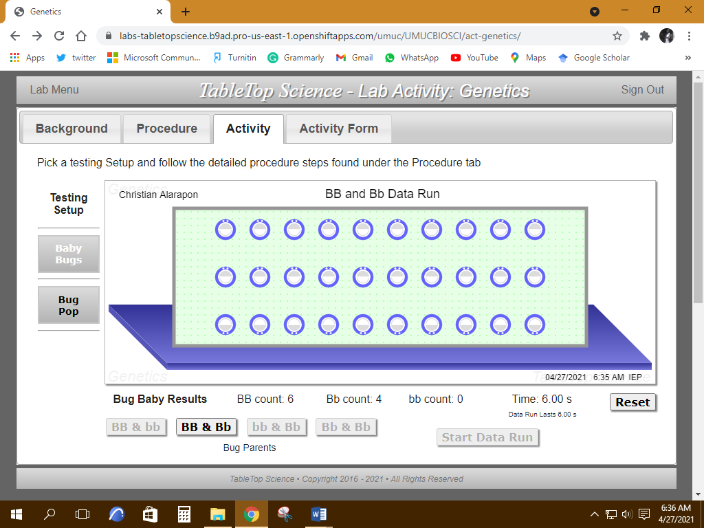
Procedure I ‐ Part B 6
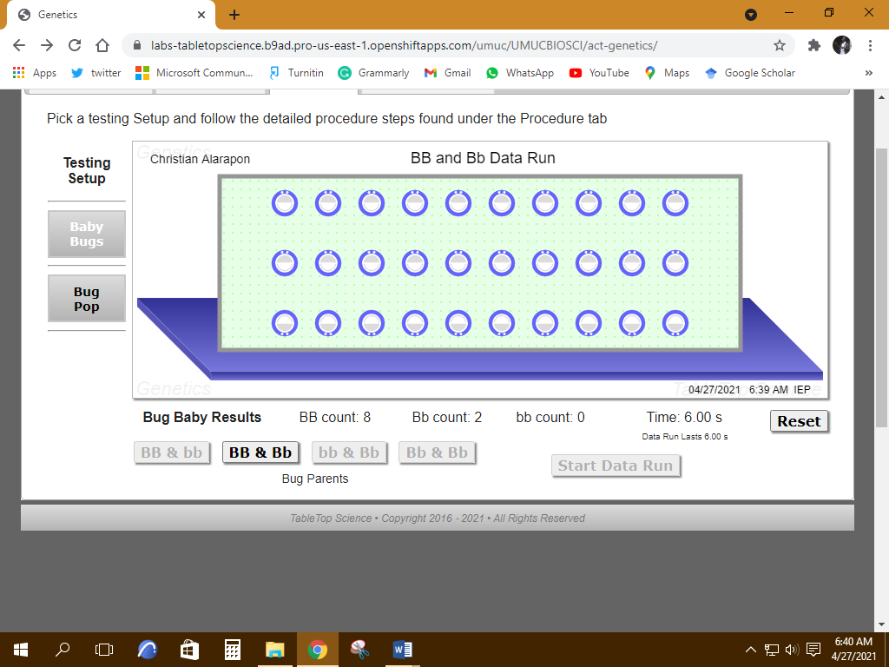

Procedure I ‐ Part B 7
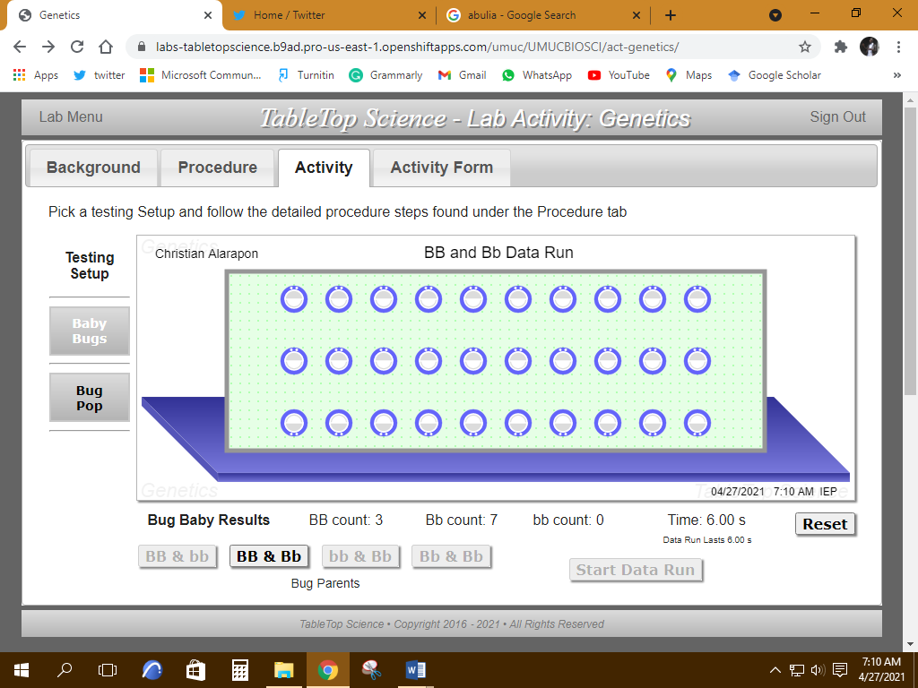
Procedure I ‐ Part B 8
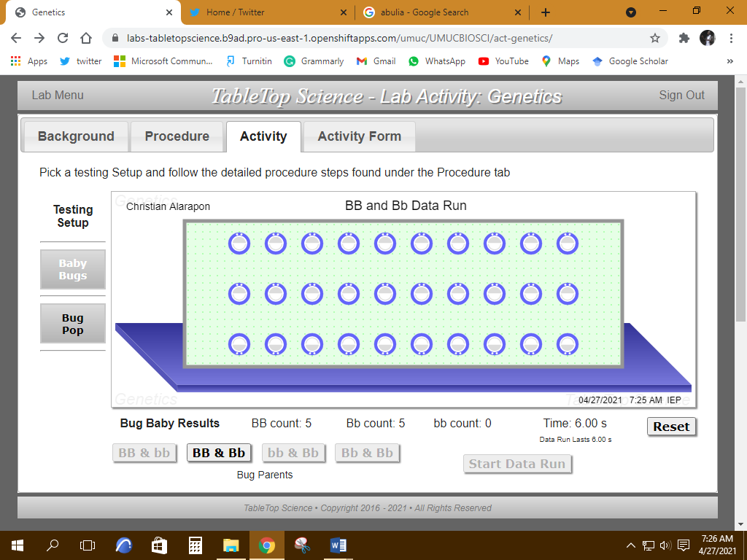
Procedure I ‐ Part B 9
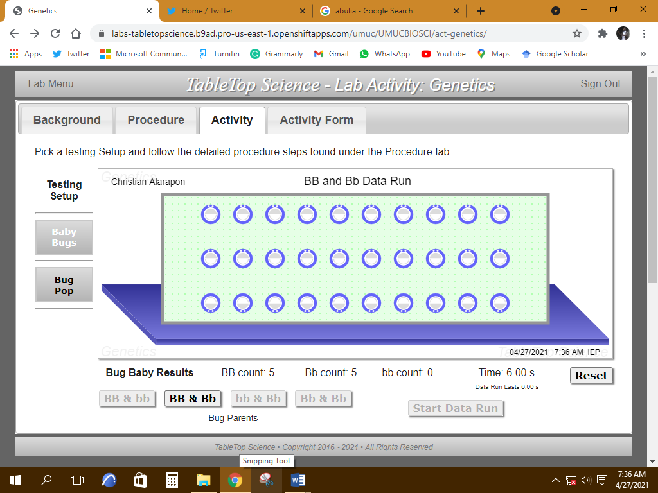

Procedure I ‐ Part B 10
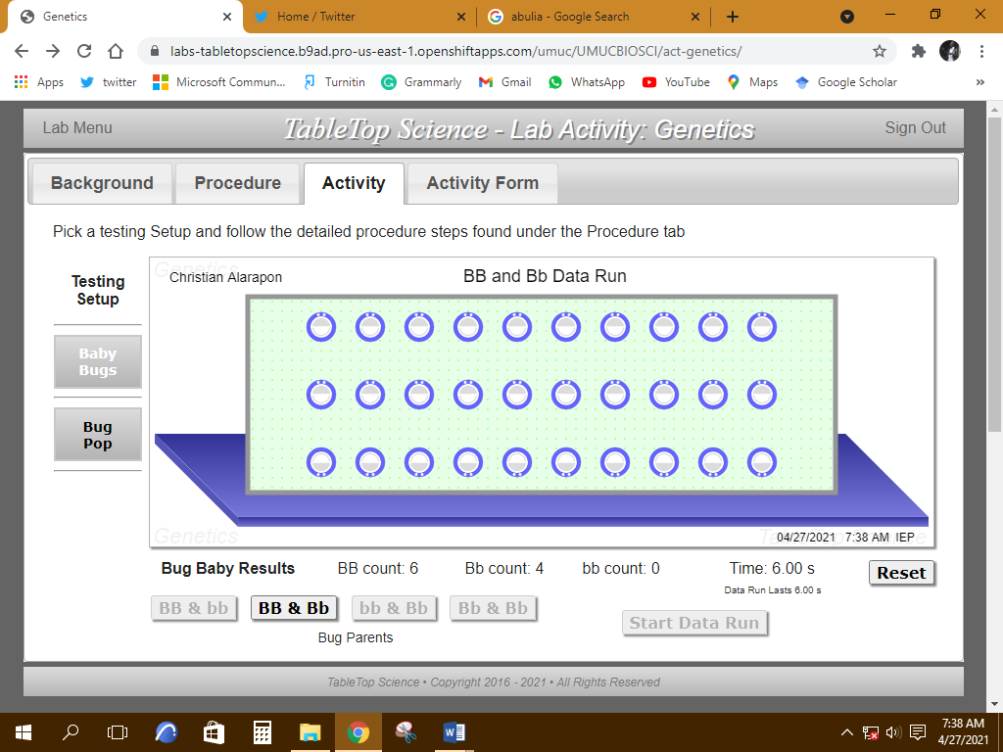

Procedure I ‐ Part C ‐ Baby bugs produced when the parents are bb and Bb
Procedure I ‐ Part C-Data Run 1
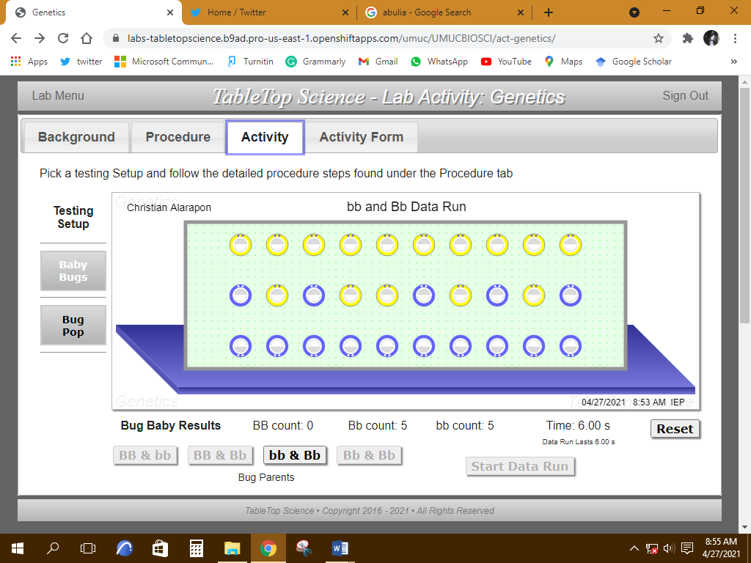
Procedure I ‐ Part C-Data Run 2
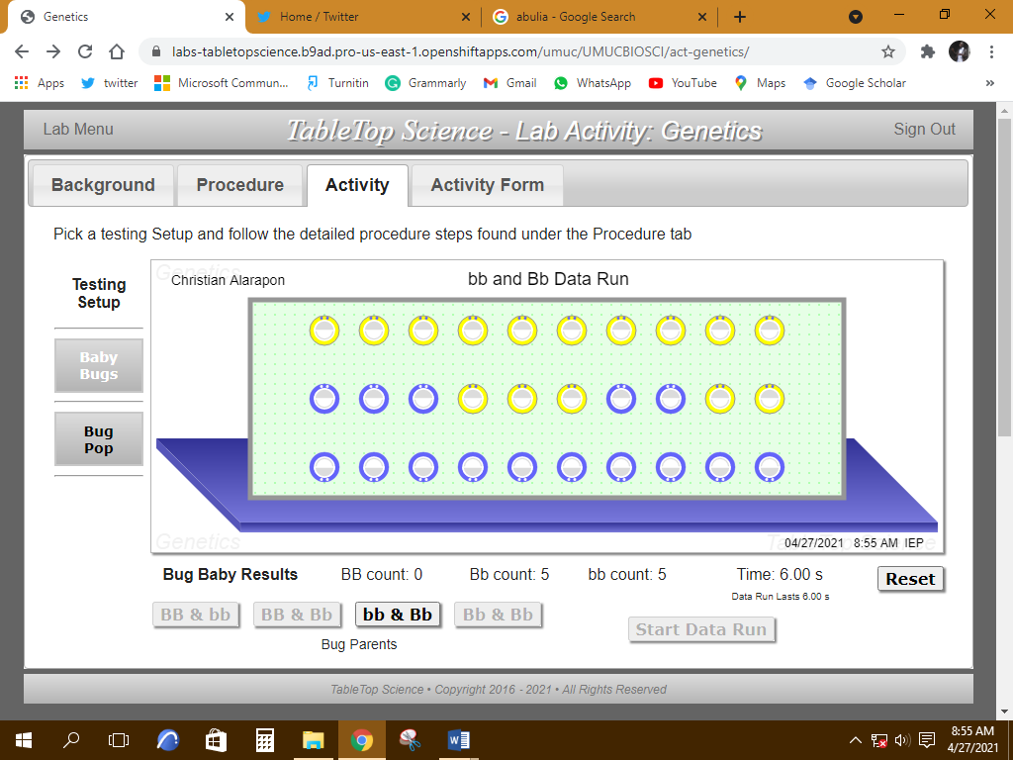
Procedure I ‐ Part C-Data Run 3
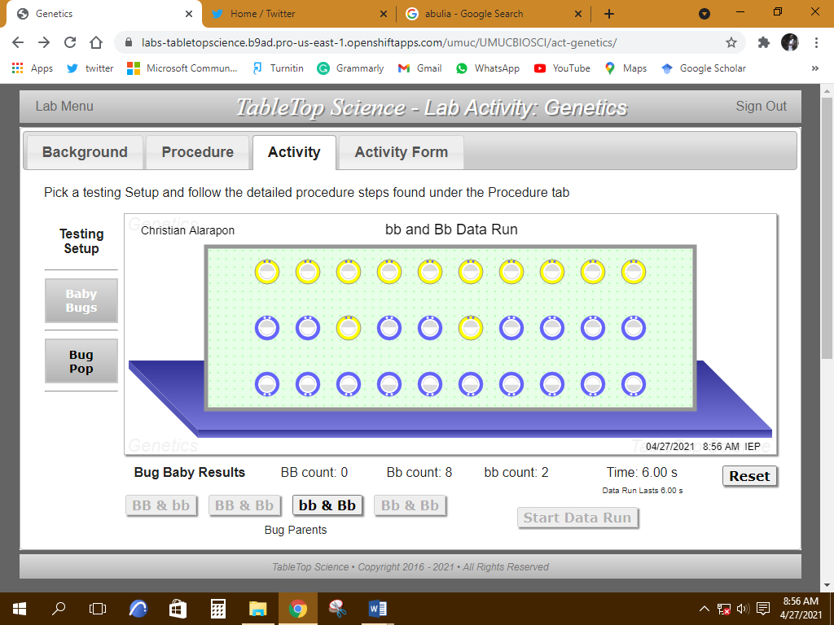
Procedure I ‐ Part C-Data Run 4
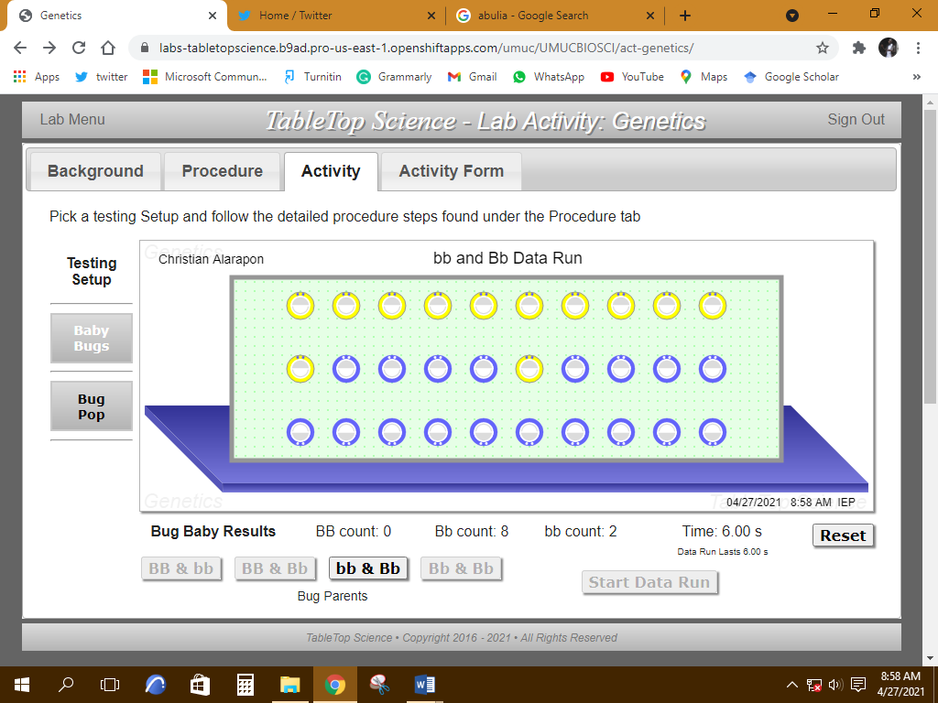
Procedure I ‐ Part C-Data Run 5
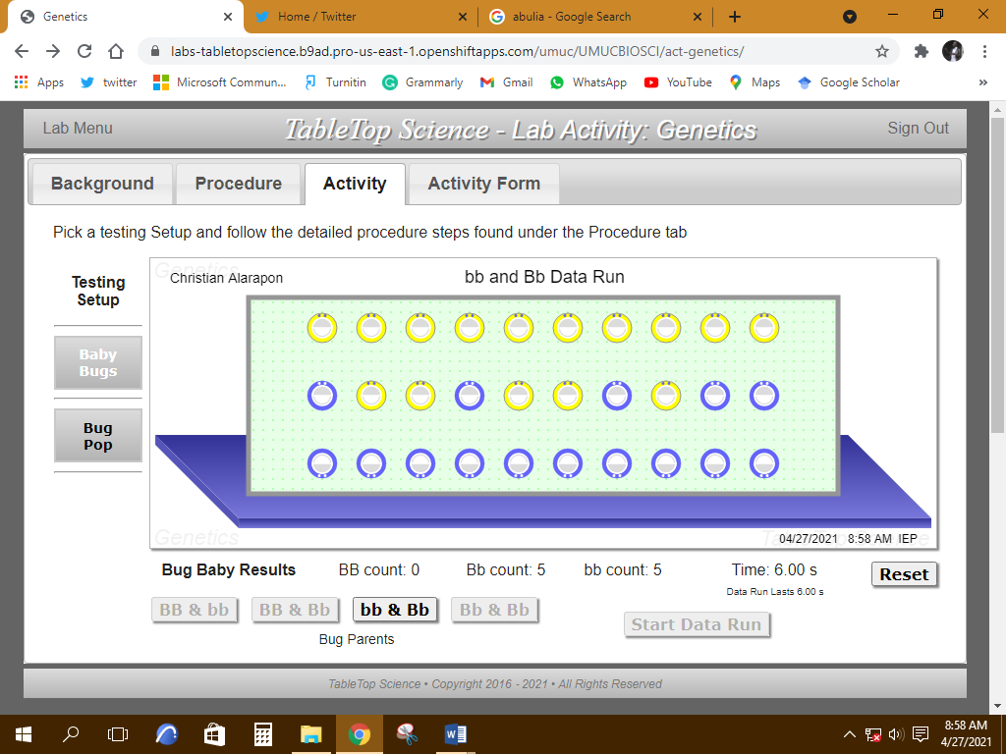
Procedure I ‐ Part C-Data Run 6
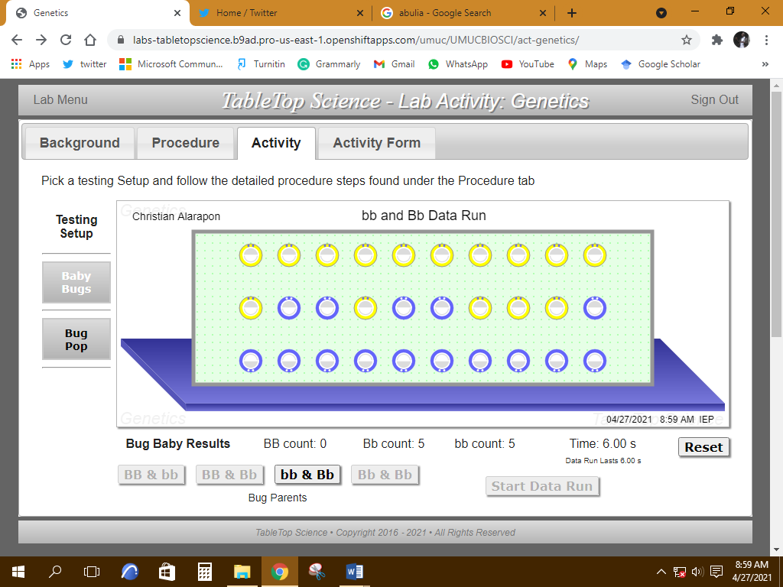
Procedure I ‐ Part C-Data Run 7
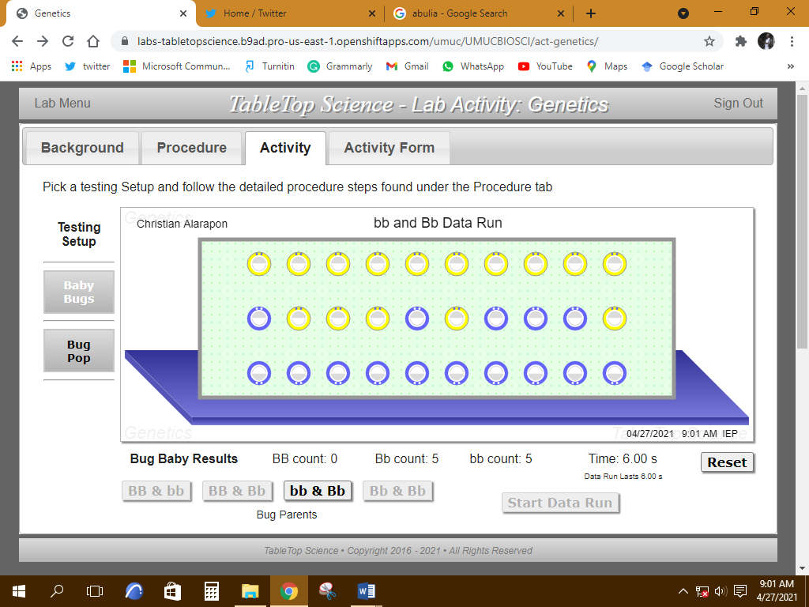
Procedure I ‐ Part C-Data Run 8
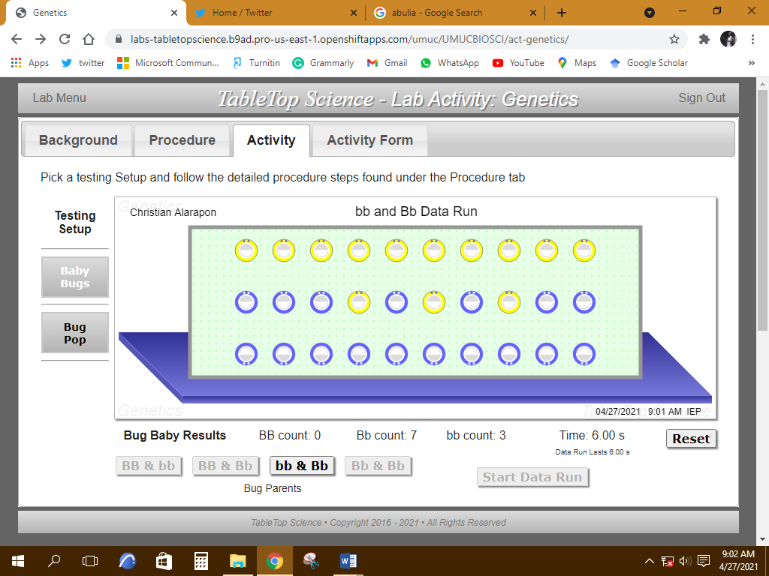
Procedure I ‐ Part C-Data Run 9
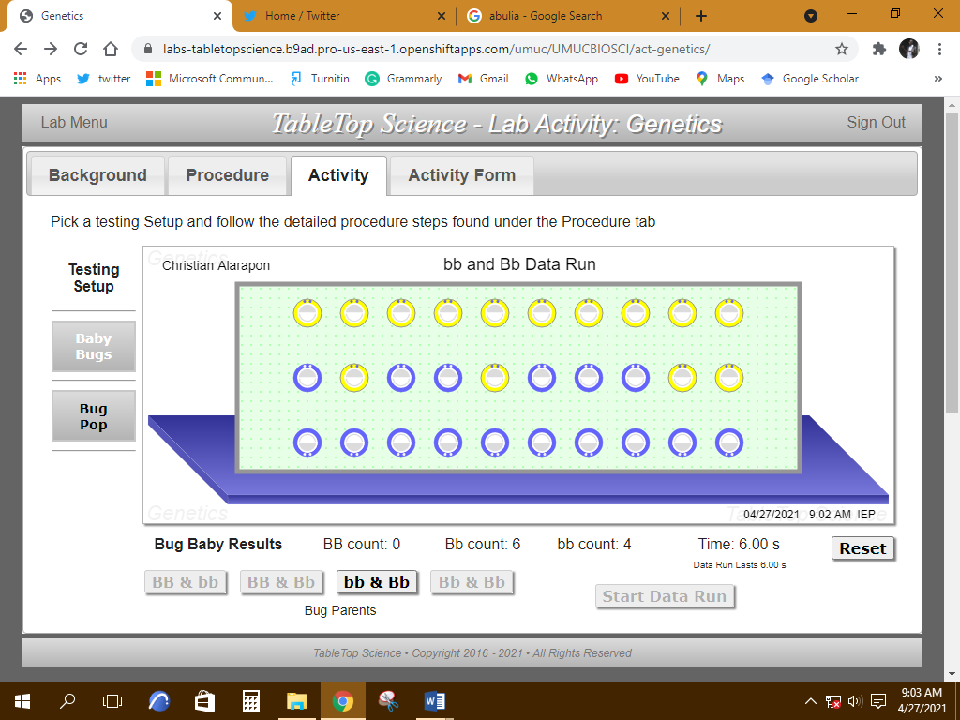
Procedure I ‐ Part C-Data Run 10
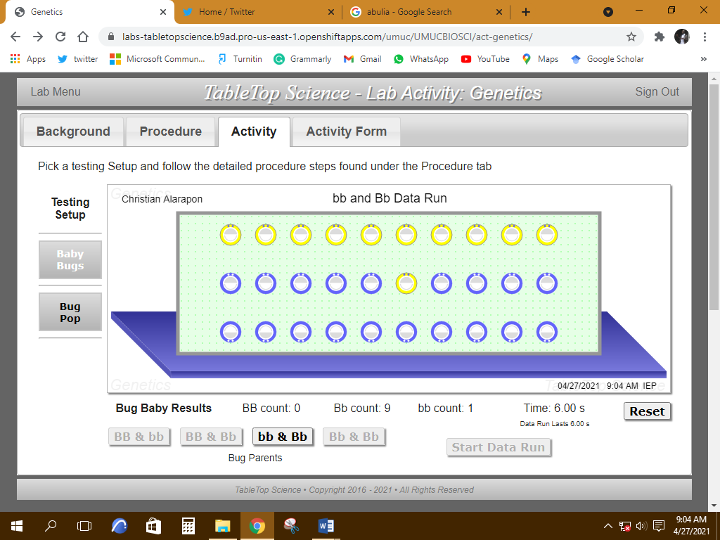

Procedure I ‐ Part D ‐ Baby bugs produced when the parents are Bb and Bb
Procedure I ‐ Part C-Data Run 1
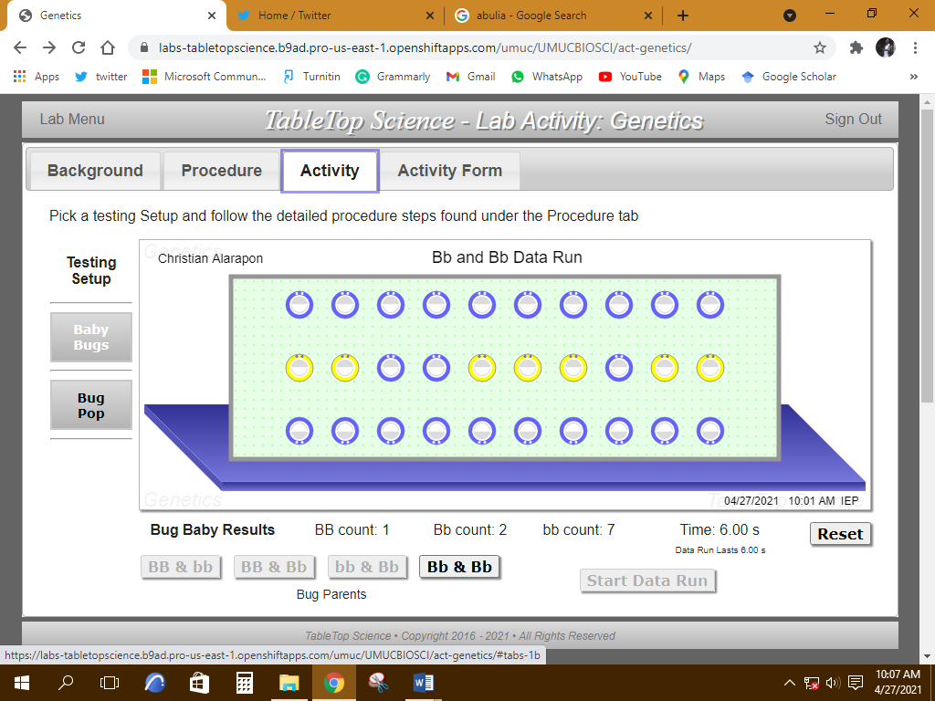
Procedure I ‐ Part C-Data Run 2
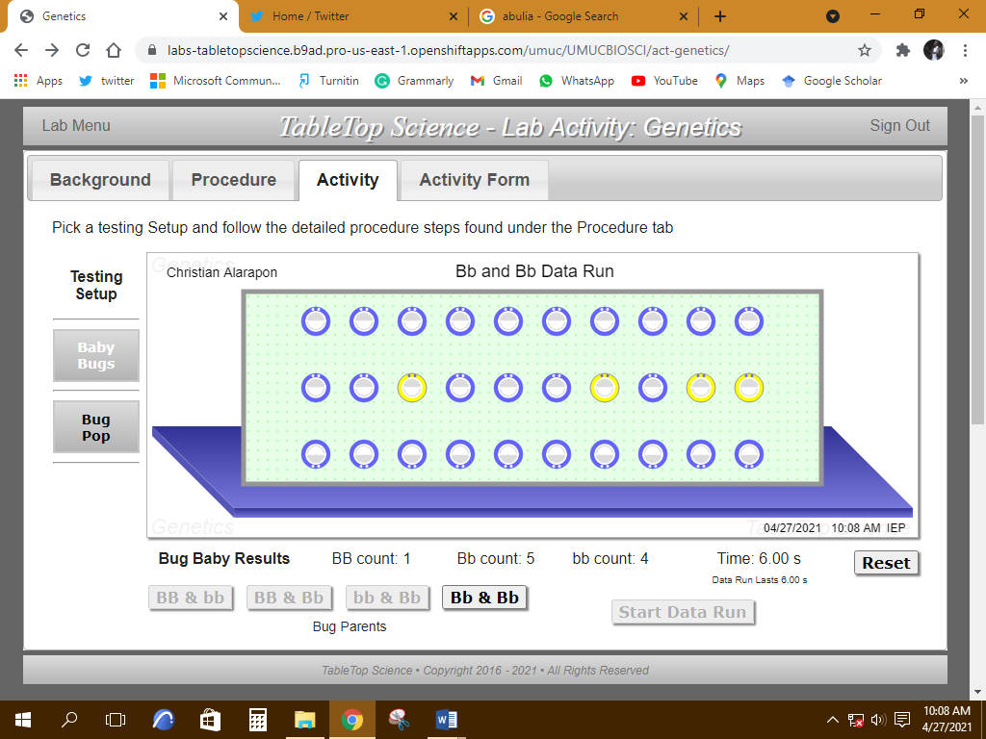
Procedure I ‐ Part C-Data Run 3
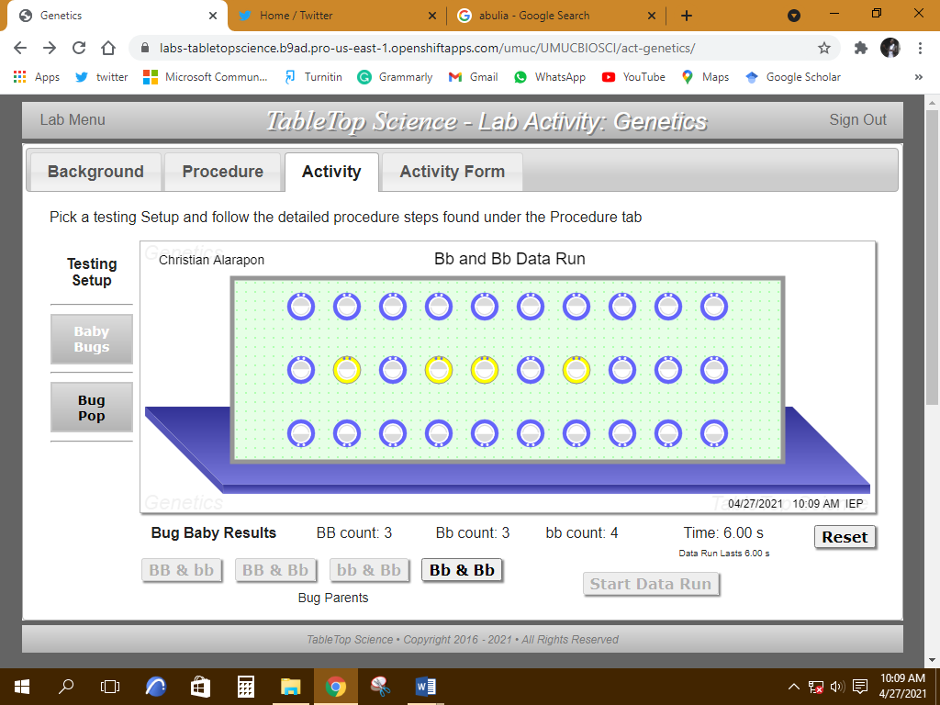
Procedure I ‐ Part C-Data Run 4
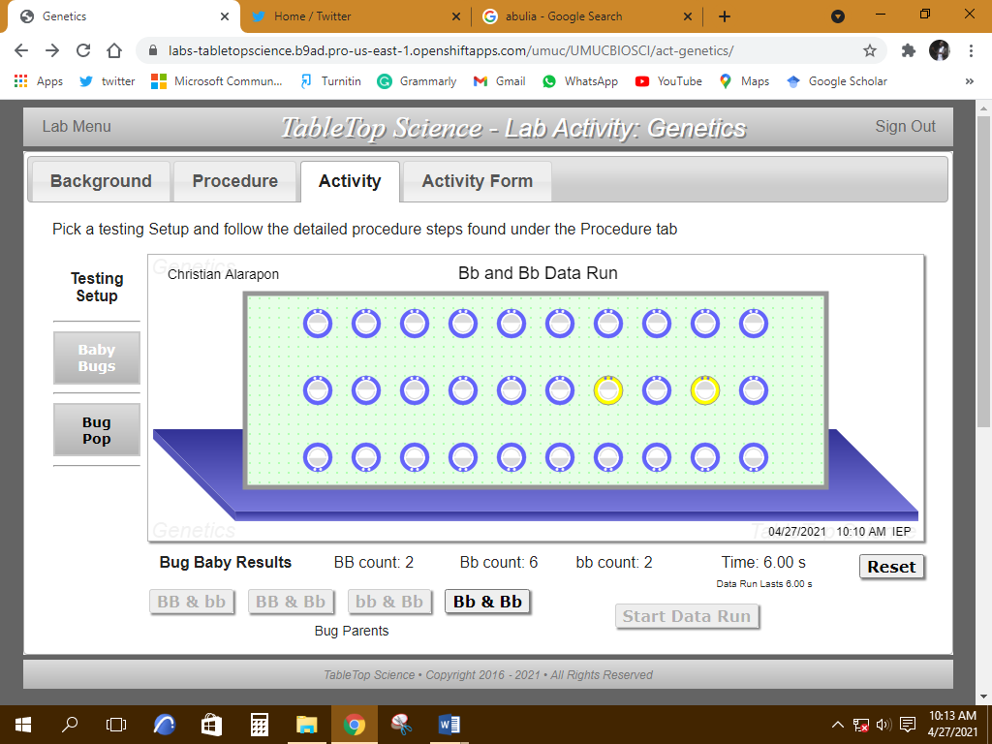
Procedure I ‐ Part C-Data Run 5
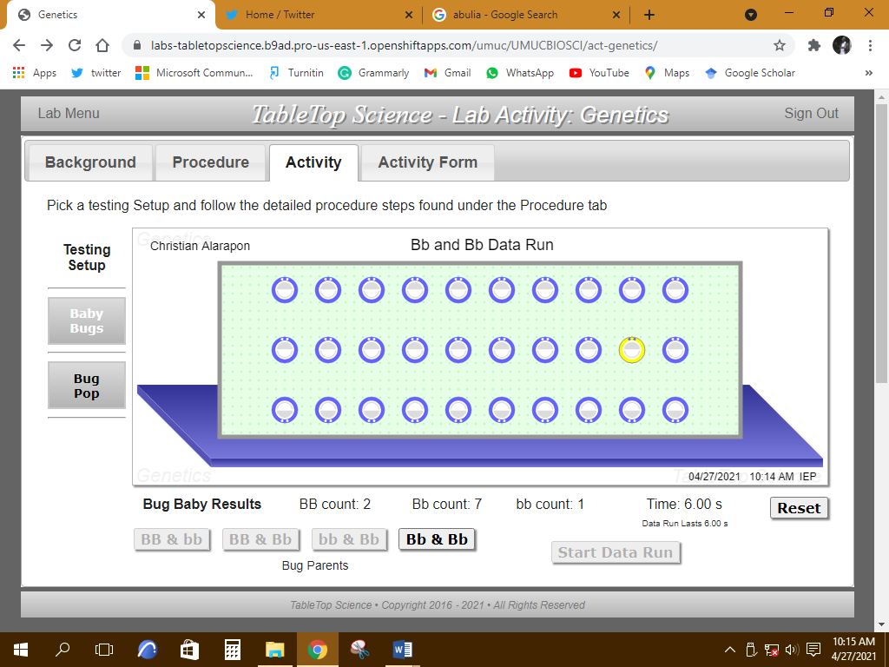
Procedure I ‐ Part C-Data Run 6
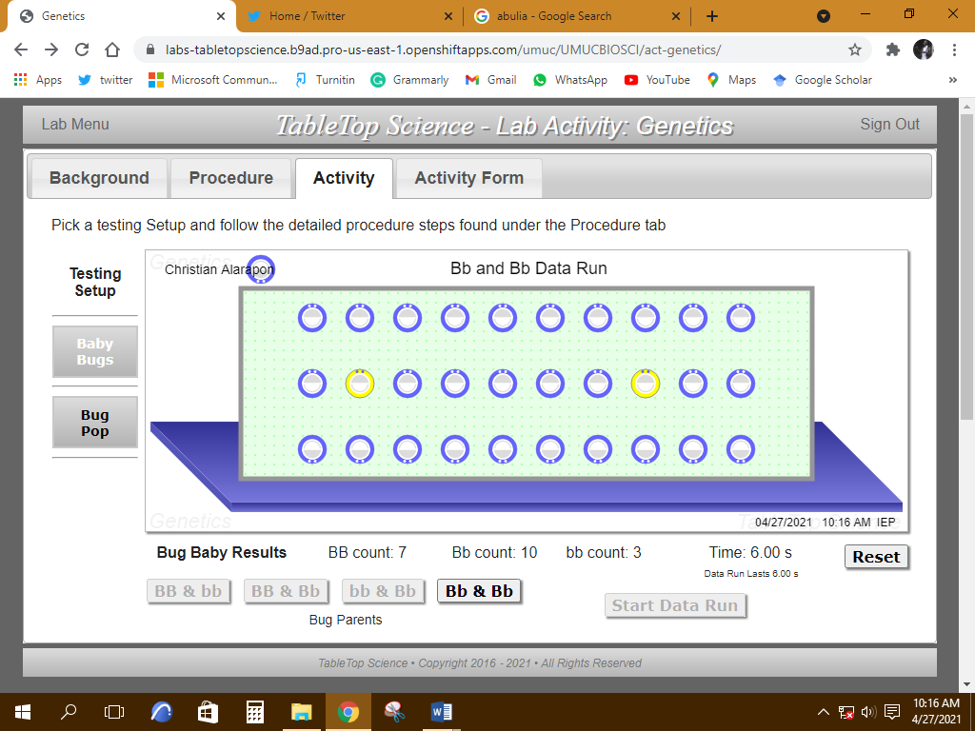
Procedure I ‐ Part C-Data Run 7
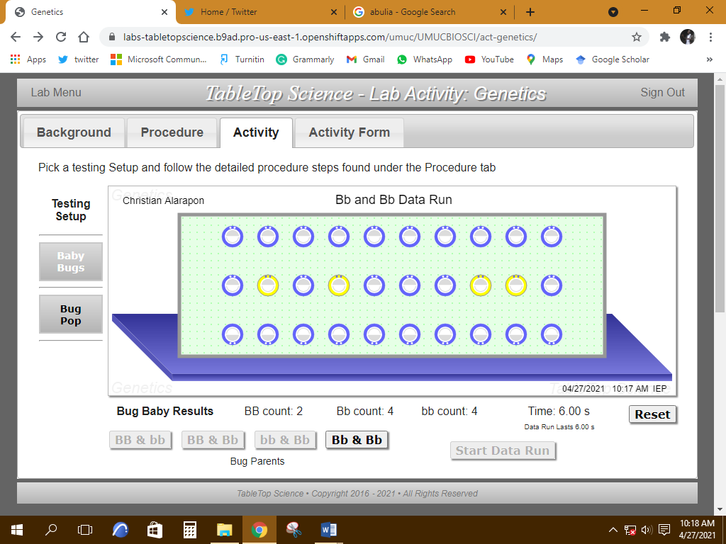
Procedure I ‐ Part C-Data Run 8
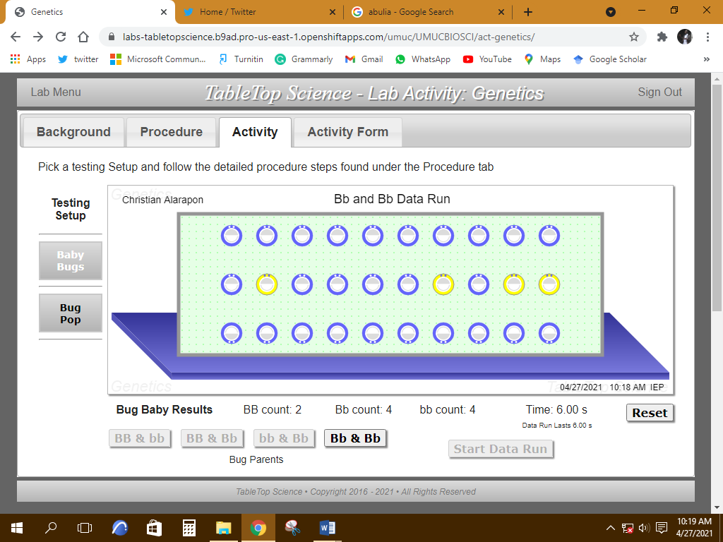
Procedure I ‐ Part C-Data Run 9
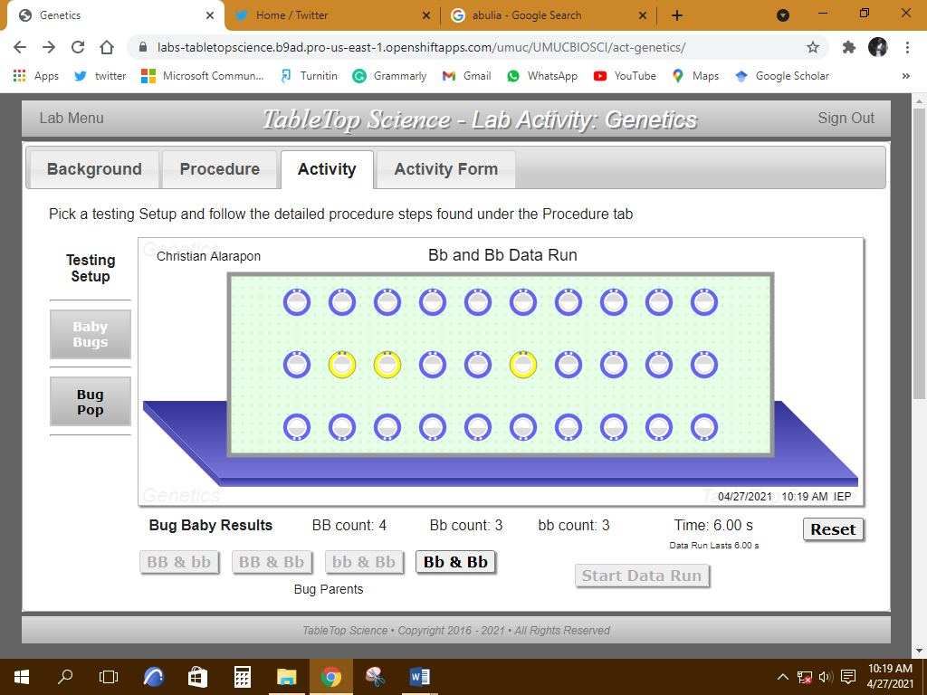
Procedure I ‐ Part C-Data Run 10
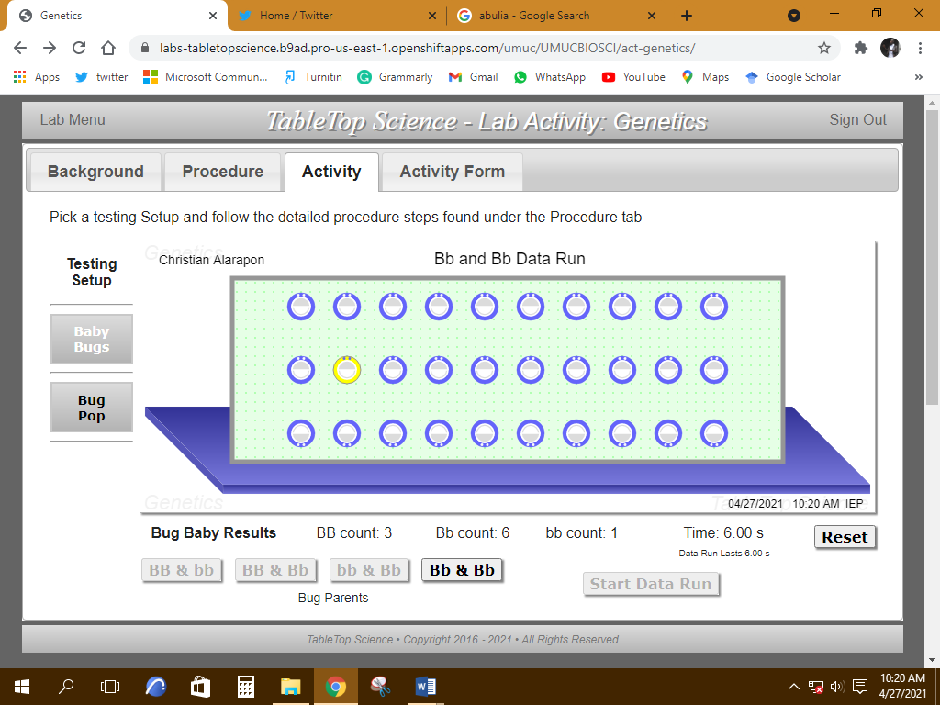

Procedure II ‐ Part A ‐ Changes in bug population over time when there is a breeding preference for blue-rimmed bugs
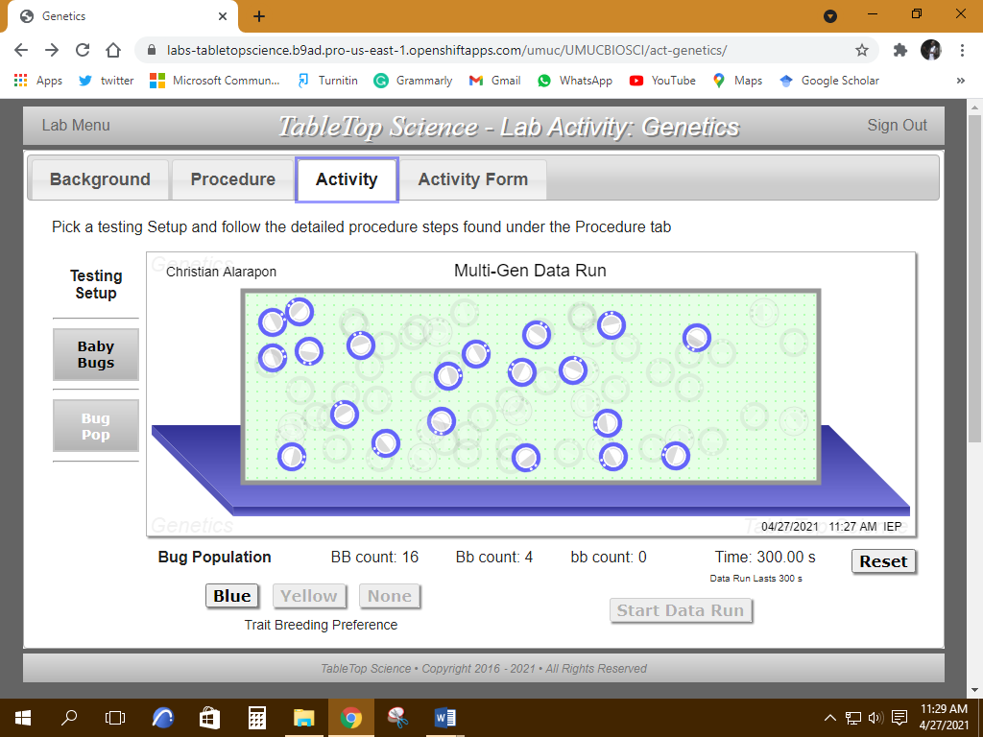

Procedure II ‐ Part B ‐ Changes in bug population over time when there is a breeding preference for yellow-rimmed bugs

Procedure II ‐ Part B ‐ Changes in bug population over time when there is a breeding preference for yellow-rimmed bugs
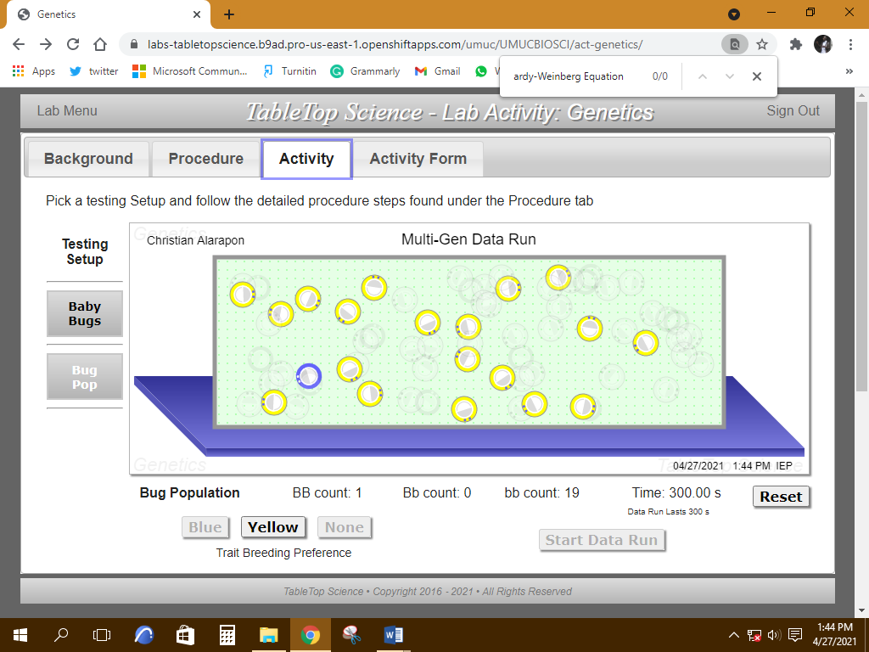

Procedure II ‐ Part C ‐ Changes in bug population over time when there is not a rim-color breeding preference
